Javier Macossay

Pre-lab #9

1. 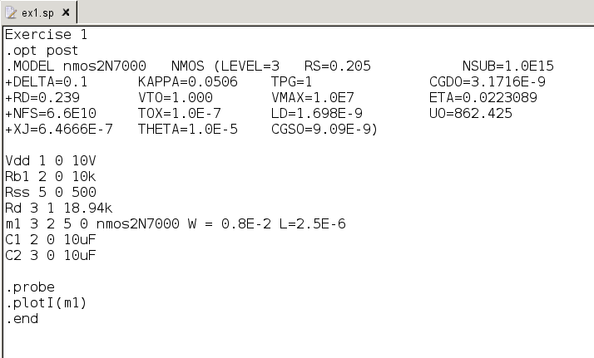

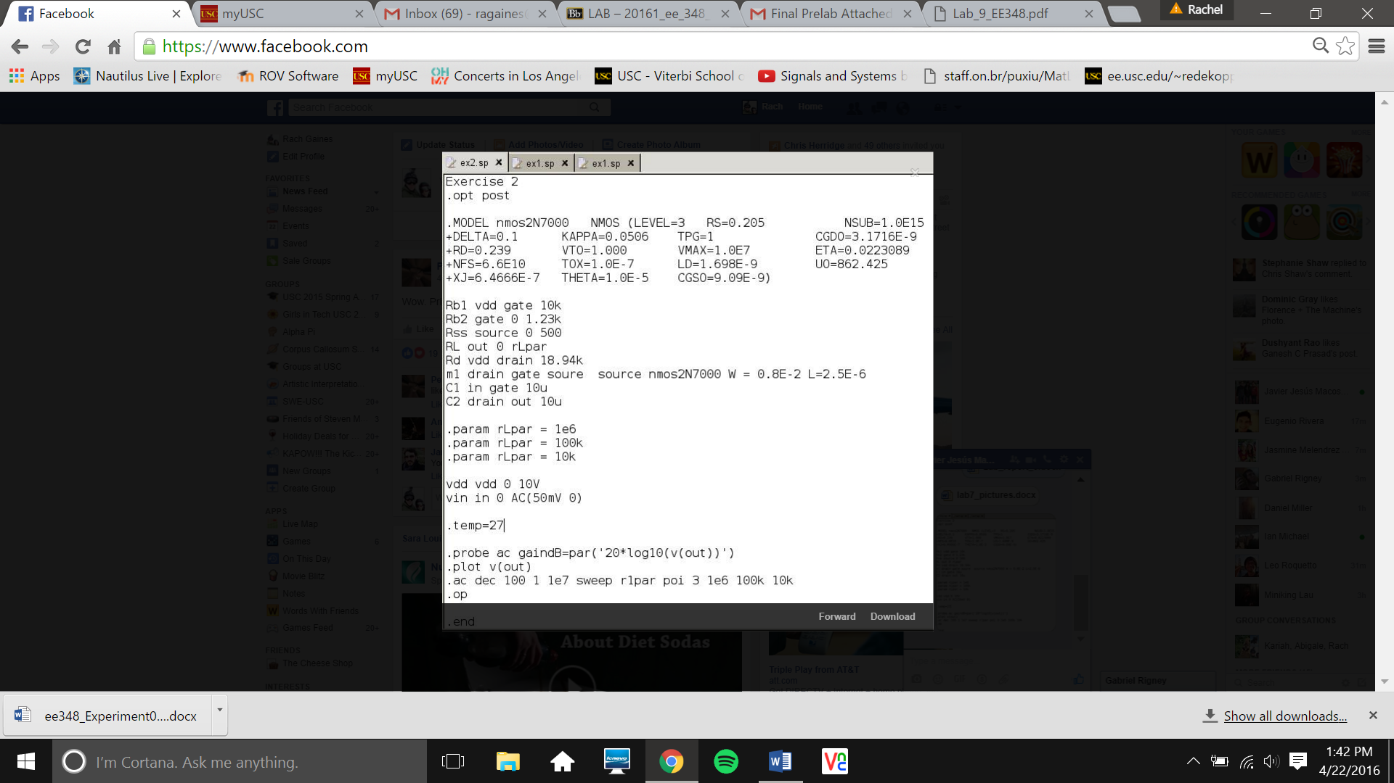  
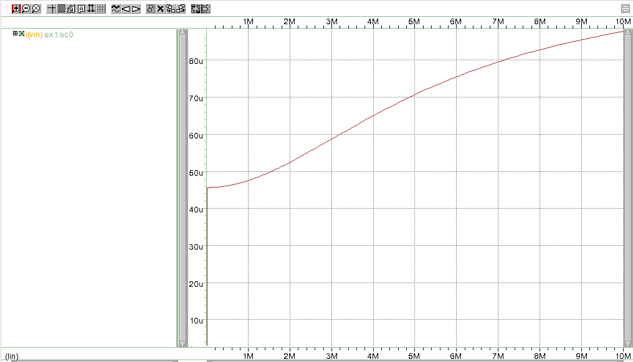  
  
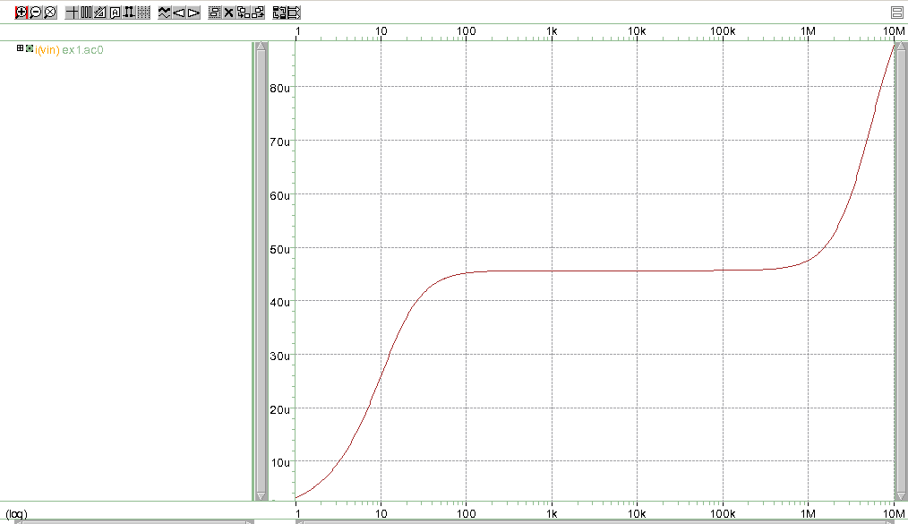

1. Given the equation: $\frac{V_{dd}}{2}=\frac{A{g_{m}}^{2}*R_{L}(1+g_{m}R_{ss})}{2K_{n}\frac{W}{L}[g_{m}R_{L}-A\left(1+g_{m}R_{ss}\right)]}$

\*In the above equation, Kn = 250\*10^-6 (A/V2) and (W/L) = 3200

We are designing our circuit with A= 28dB = 10^(28/20) = 25.12 (V/V)

Vdd = 10V

Rss = 200Ω

We will be ranging RL from 100Ω to 100kΩ, but we want the circuit to support a minimum RL of 10kΩ, so we will be using RL=10kΩ for the equations above.

Plugging the values above into the equation yields:

$$5\left(V\right)= \frac{25.12{g_{m}}^{2}(10(kΩ)+2\left(kΩ^{2}\right)g_{m})}{1.6\left(\frac{A}{V^{2}}\right)*[10\left(kΩ\right)g_{m}-\left(25.12+5.023\left(Ω\right)*g_{m}\right)]}$$

Solving for gm yields the following solutions (in units of 1/Ω):

gm = -.0328 (This answer can be thrown out because a negative gm­ has no physical interpretation)

gm = .00544

gm = .0224

Using the equation: $I_{D}=\frac{{g_{m}}^{2}}{2K_{n}\frac{W}{L}}$

Plugging in gm = .00544 (1/Ω) yields ID = 18.477μA, which is below the threshold 100 μA, so gm = .00544 (1/Ω) can be thrown out.

Plugging in gm = .0224 (1/Ω) yields ID = 313.664μA, which is above the threshold 100 μA, so gm = .0224(1/Ω) is a good result for our circuit.

Using this gm value, we will solve for RD = = 15.85kΩ